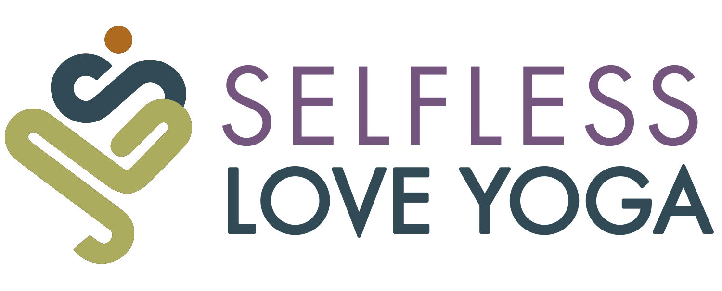
STUDENT RELEASE AND WAIVER OF LIABILITY AGREEMENT

Name: Date of Birth: / / .

Email: (this will be your MindBody online user name)

Address/City/State/Zip: .

Phone: - - Emergency Contact: .

How did you hear about us? .

⬜ Check box if you would like to receive reminders & schedule changes via MindBody.
⬜ Check box if you would like to subscribe to upcoming news & promos.

Have you ever practiced yoga before? (Circle one): Yes / No

It is your responsibility to inform the instructor of your limitations before class begins. Please list any injuries, medical issues, important medical history, and any physical limitations that could be aggravated by exercise (i.e. back, neck, shoulder or knee problems):
.
.

I (print name) represent and warrant that I am in good physical health and do not suffer from any medical condition which would limit my participation in the classes offered at Selfless Love Yoga. Participation in yoga class includes, but is not limited to, participation in meditation techniques, yogic breathing techniques, and performing various yoga postures. Yoga postures, or asanas, are designed to exercise every part of the body―stretching and toning the muscles and joints, the spine and the entire skeletal system. They also work on the internal organs, glands and nerves. Yoga is an individual experience. I understand that it is my responsibility to consult with a physician prior to and regarding my participation in any of the yoga classes, programs, or workshops held at Selfless Love Yoga, LLC. I understand the risks associated with the activities offered and I agree to follow all instructions so that I may safely participate in classes, workshops, or other activities.

As is the case with any physical activity, the risk of injury, even serious or disabling, is always present and cannot be entirely eliminated. My signature acknowledges I understand that in yoga class, I will progress at my own pace. If I experience any pain or discomfort, I will listen to my body, adjust the posture and ask for support from the yoga teacher. If at any point I feel overexertion or fatigue, I will respect my body’s limitations and I will rest before continuing yoga practice. Yoga is not a substitute for medical attention, examination, diagnosis or treatment. By signing my name below, I acknowledge that participation in yoga classes exposes me to a possible risk of personal injury. I am fully aware of this risk.
I hereby take action for myself, my executors, administrators, heirs, next of kin, successors and assigns as follows: I (a) irrevocably WAIVE, RELEASE AND DISCHARGE FROM ANY AND ALL LIABILITY for my death, disability, personal injury, property damage, property theft or actions of any kind which hereafter may occur to me, including my traveling to and from yoga classes, Teacher and Selfless Love Yoga, LLC, who is hosting these classes and where sessions are being held, and each of their directors, officers, employees, volunteers, representatives and agents; and (b) INDEMNIFY, HOLD HARMLESS AND AGREE NOT TO SUE the entities or persons mentioned in this paragraph as to any and all liabilities or claims made as a result of participation in the yoga classes, whether caused by the negligence of releasees or otherwise.
My signature further acknowledges that I shall not now or at any time in the future bring any legal action against Teacher and/or Selfless Love Yoga, LLC; and that this waiver is binding on me, my heirs, my spouse, my children, my legal representatives, my successors and my assigns. My signature verifies that I am physically fit to participate in yoga classes and a licensed medical doctor has verified my physical condition for participation in this type of class. If I am pregnant or become pregnant or am post­natal, my signature verifies that I am participating in yoga classes with my doctor’s full approval. I realize that I am participating in yoga classes at my own risk.
The Student Release and Waiver of Liability Agreement shall be construed broadly to provide a release and waiver to the maximum extent permissible under applicable law. I acknowledge that this Student Release and Waiver of Liability Agreement form will be used by the persons or entities being released in the yoga classes and other activities and that it will govern my actions and responsibilities in said classes.

I hereby certify that I have read this document; and, I understand its content. I am competent to sign and I am aware that this is a release of liability as well as a contract and I sign it of my own free will agreeing to the terms and conditions stated above.

Print name: Signature: .
Date Signed: / / ,

If participant is under 18:
As Parent or Legal Guardian of , I consent to the above terms and conditions on their behalf and my signature above certifies this.

